Sessions and Upcoming Events
This term our gymnasts are working towards two events to be held in our club.
The first event is our Burst your Bubble Gym Fest for our Competitive groups STEP 1 -6 is to be held on September 5th, more information will be sent to those gymnasts in the coming weeks. Clubs from Whangarei and as far away as Piako in the Waikato region will be attending.

Our Gym For All Gymnasts are working on routines made up by their coaches. The routines that they are learning will be showcased at our second event which is our Annual Ribbon Day to be held on the 31st October.

We will be asking for your support on these days and will offer a volunteer roster for the jobs available.
Term 3 2020
Welcome to back to Kerikeri Gymnastics!
Thanks for joining us this term, after a tumultuous early part of the year and Covid19 restrictions, we hope you find fun and friendship in your gymnastics sessions this term. We are super pleased to have all our gymnasts back safely and speedily to continue their competition and recreational programmes.
Thankyou for those who have paid their fees promptly. These fees are crucial to the running of the club. Please speak with Janet or committee if you are having difficulty paying your fees.

COACHES
Our coaches this term are Head Coach Gym For All Janet, Head Coach Competitive Sarah, Senior Coach for Mens gymnastics Tyler, Gym for All coaches are Rebecca, Anna, Zoe, Amber, Jess, Cole, Alice. Our competitive coaches are Belinda, Ashley, Kerri, Anna, Zoe, Alice and Grace.

Gym Club Hoodies!
Perfect for winter and a fundraiser for Ribbon Day!
3 styles available; Women’s Men’s and Children’s sizes.
Prepaid orders only, must be paid by August 7th
(Cash or online invoice).
See order form at club.
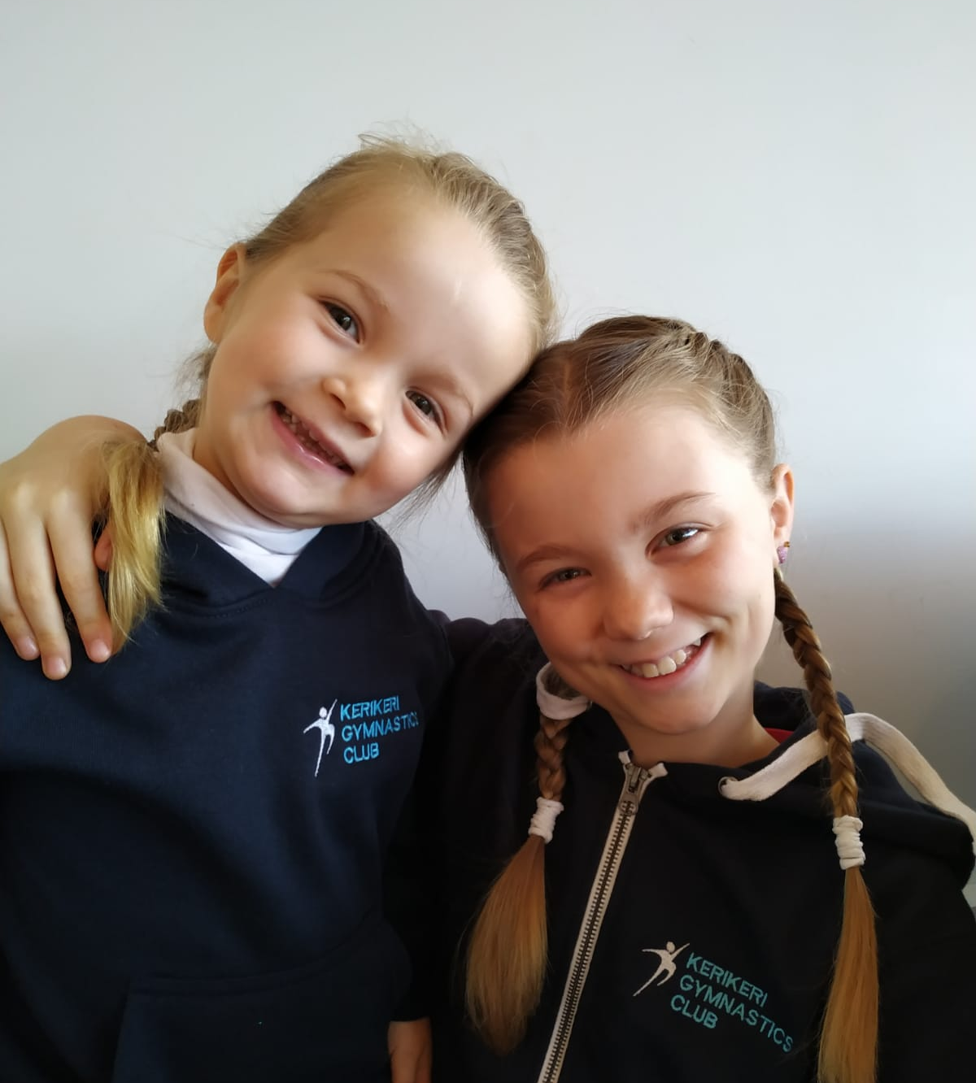
10PLAY PLAYGYM
Playgym class times for preschoolers are Monday 9.30 – 10.30 , Tuesday 930 – 10.30, Thursday 11.30 – 12.30 and Friday 1.30 – 2.30.
Cost $5 per child. Our Playgym leaders are Janet, Sarah, Ashley and Michelle
n your diary!!

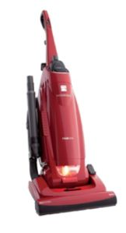
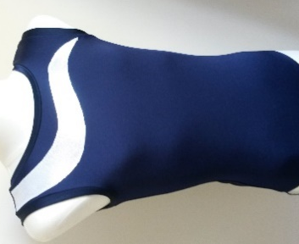
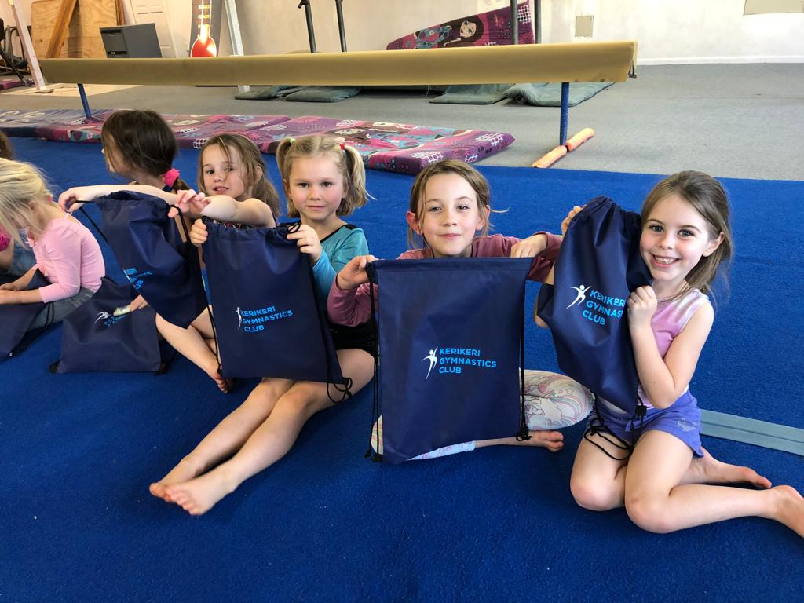
Our club leotards are a perfect choice for gymnasts to exercise/train in, navy and silver in short ($50) or long sleeve ($60)

[Cite your source here.]
We need you!
If you can help with cleaning/vacuuming (approx. one hour per term), please sign up on notice at gym. If anyone knows of a good quality vacuum cleaner that removes hair, please let one of the committee know or txt/email Rebecca at 0273727712 or tomandbeck4@gmail.com

Interested in Coaching?
Our Gym For All classes are now full, which is fantastic. We would love more children to take part in this fantastic sport but we are short of coaches, so we are looking for more coaches to assist in these classes. If you have had a background in gymnastics as a child, (it’s never too long ago) or if one of your older children use to come to gymnastics and is wondering what to do with themselves after school, or in a gap year, we would love to hear from you. We need help at 3.30 – 4.30 class times, Mon – Wed and with our teenage girls class Tuesday and Wednesday 4.30 -6.30pm.

REMINDERS:
- Please do keep your child home if they are unwell and encourage good hand hygiene. We ask that gymnasts use hand sanitiser before their session.
- Please ensure your child has correct fitted training clothing/leotard and it is essential that hair is tied back securely.

Jack’n’Jill Portraits
KKGC Photo fundraiser booked for 17th and 18th October. We need your support to fill the photo slots. A great Christmas gift!!

WE are always looking for other venues/location if we are unable to remain in the current building. speak to janet if you know of a large building with a high stud.

THANKYOU!!
A massive thanks to the Chenery Memorial Trust for $1690 for club kit form members (bags and coach apparel). Huge thanks also goes to local business Sweeter Academy for fundraising
display and Committee hoodies.

nd a huge Thank yo

LIKE “Kerikeri Gymnastics Club Incorporated” for the latest news!

KERIKERI GYMNASTICS CLUB
2020 Fees

PROGRAMME | CLASS DURATION (HOURS) | FEE
RECREATIONAL | 1 | $110.00
 | 1.5 | $130.00
 | 2 | $140.00
 | 2.5 | $150.00
DEVELOPMENT | 1 | $120.00
 | 1.5 | $135.00
 | 2 | $160.00
COMPETITION | 1 | $140.00
 | 1.5 | $150.00
 | 2 | $160.00
 | 2.5 | $170.00

The following discounts are given to all members that participate in 2 or more classes per week:
- 15% (2 classes)
- 25% (3 or more classes).

